**ASSIGNMENT ON FIND COMMAND:-**

1. To find a file by it's name in a given dir.

find /location/dir -name <file_name>

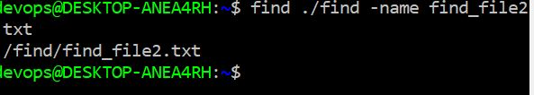

2. To find a file by it's type.

find /location/dir -type "*.txt"

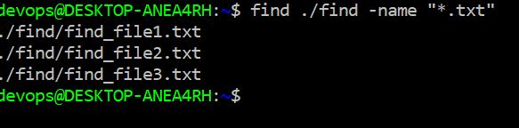

3.To find a file ignoring case sesitivity

find /location/dir -iname <file_name>

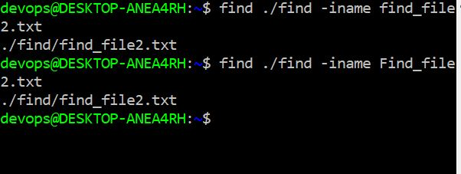

4. To search a file belogs to sepcific user

find /location/dir -user <user_name>

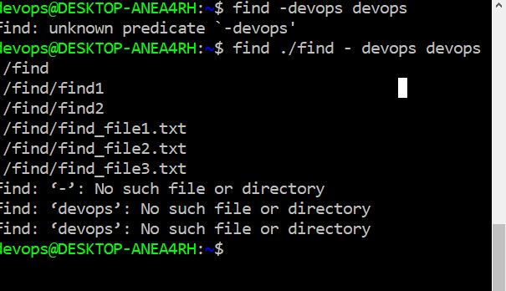

5. To find file based on permissions

find /location/dir -perm <set_of permission>

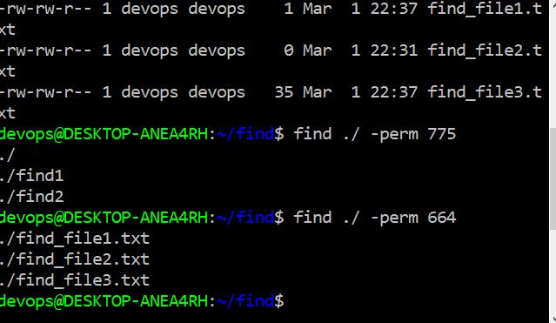

6. To search files by date-time stamp

find /location/dir -mtime <duration>

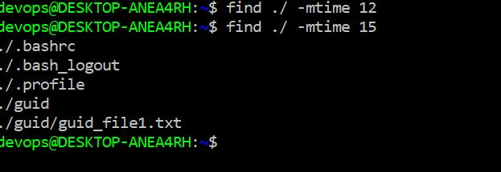

By using find command search all empty file in a given dir and also delete those files.

